https://github.com/hiImDeni/flcd

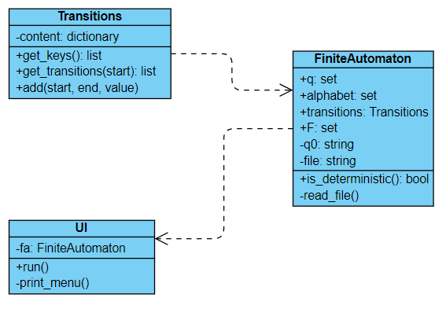

Meaning of file:

* Line 1: set of states, intial state is the first one from the set
* Line 2: alphabet
* Line 3: set of final states
* Line 4-eof: transitions